Installation
of
ODIN 10x Client Software

To download the CLIENT Dealer please click on the below link and save it in your c-drive.
http://intra.cdequi.com/downloads/client_setup.zip
Extract the Files in Folder /CD ODIN SETUP
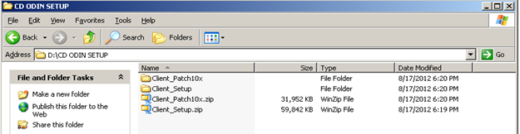
Open Client _Setup ODINCLIENTCLIENTDisk1
Double click in setup.exe
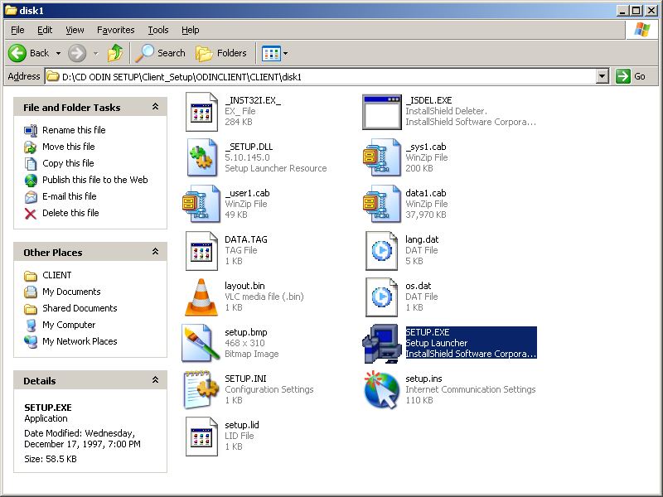

Click on OK
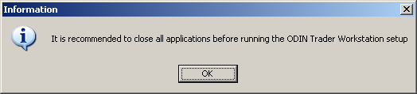

Click Next
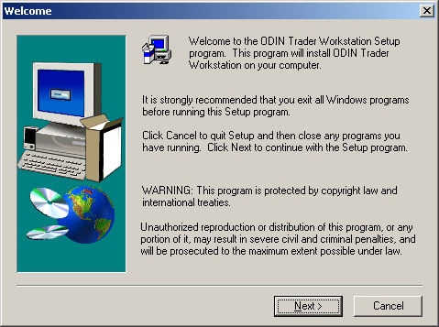
Click YES
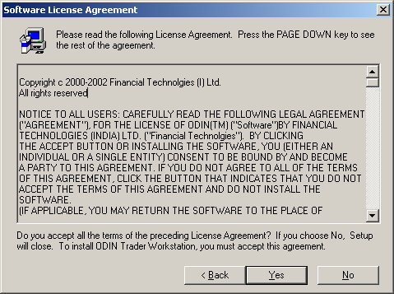

Click Next
Type Serial 91638-10001
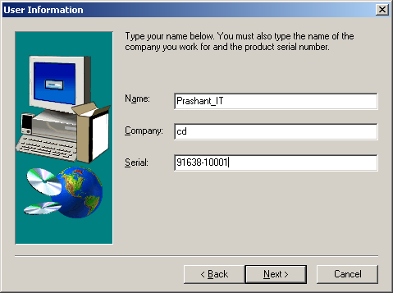

Click Next
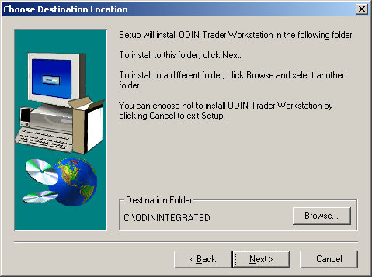

Click Next
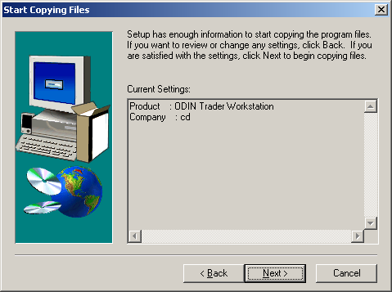

Click Next
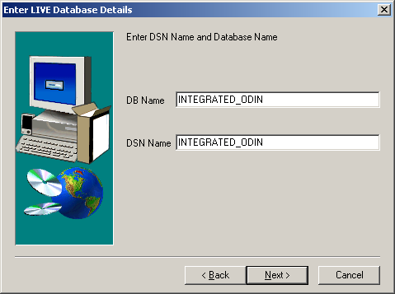

Click Next
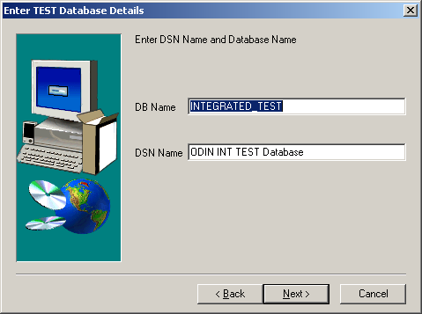

Click Next
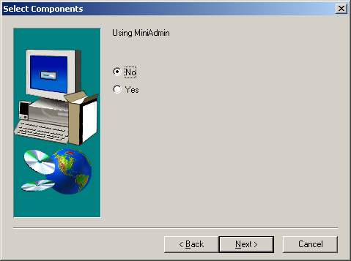

Click Next
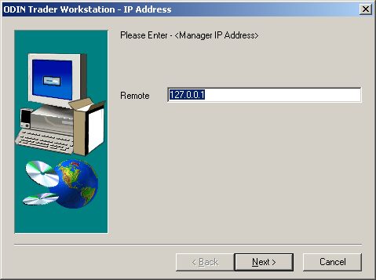

Click Next
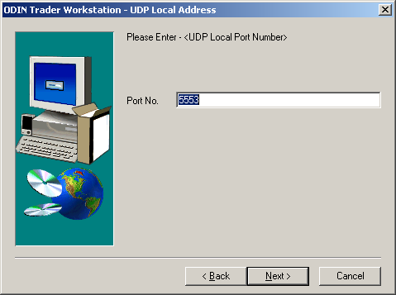

Click Next
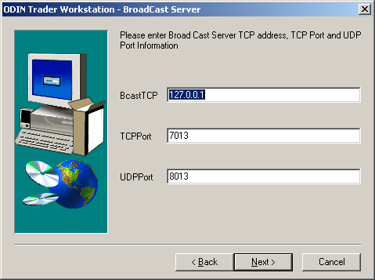

Click Next
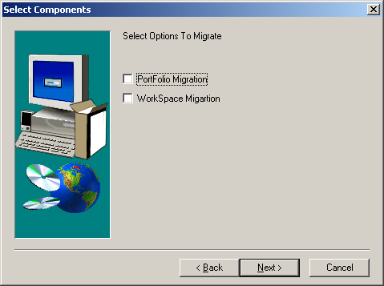

Click Finish
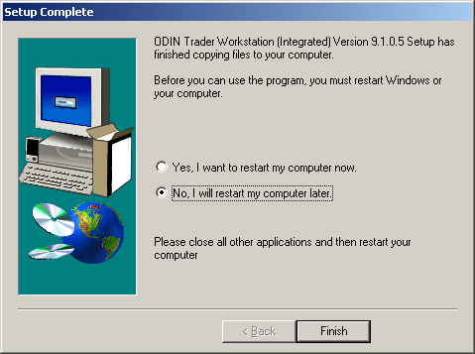

Open Client _Setup ODINCLIENT\Report\ Dlls\disk1
Double click on setup.exe
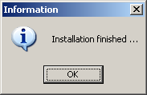
Click OK
Open Client_Setup\ODINCLIENT\Sysdll\disk1
Double click on setup.exe
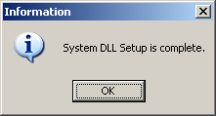
Click OK
Open Client_Setup\ODINCLIENT\
Double click on vcredist_x86.exe
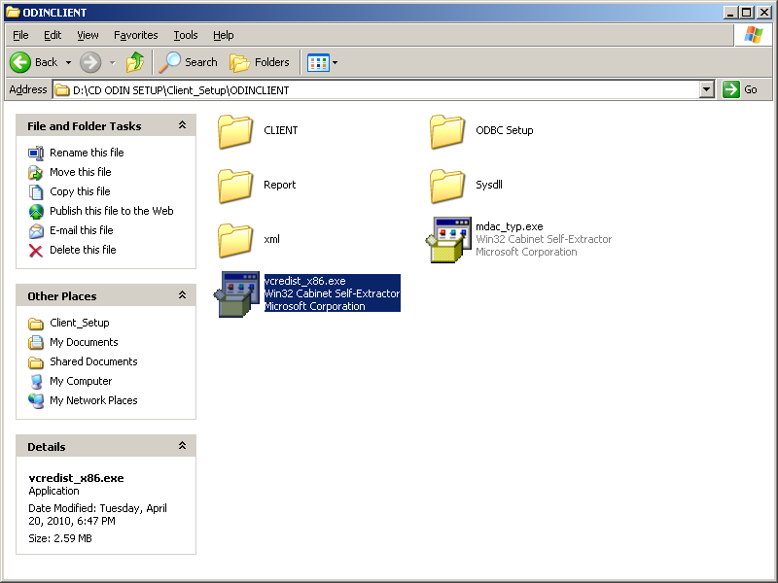
Click Yes
