To download the CLIENT Patches please click on the below link and save it in your c-drive.
http://intra.cdequi.com/downloads/Client_Patch10x.zip
Extract the Files in Folder /Client_Patch10x
Double click on CLI32BIN_10X_MIG_SP07.exe
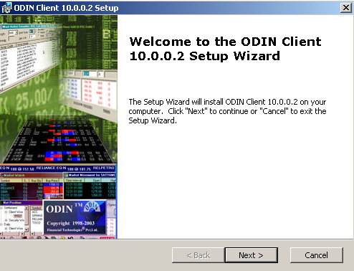
Click Next
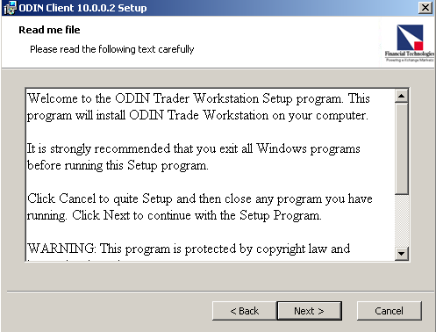
Click Next
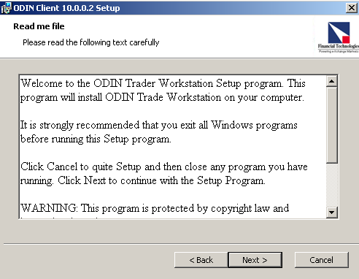

Click I Accept
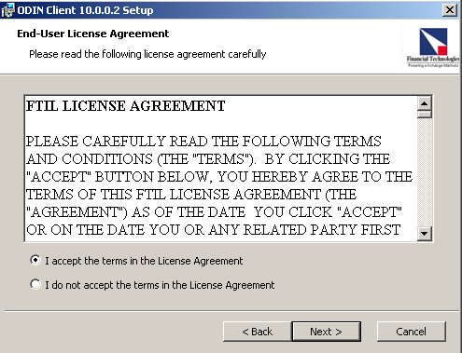

Click Next
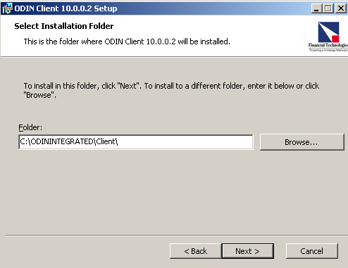

Click Install
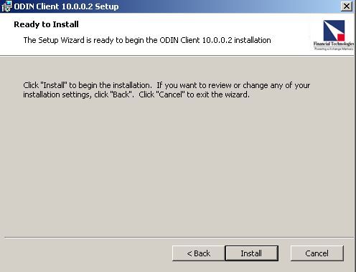
Click Finish
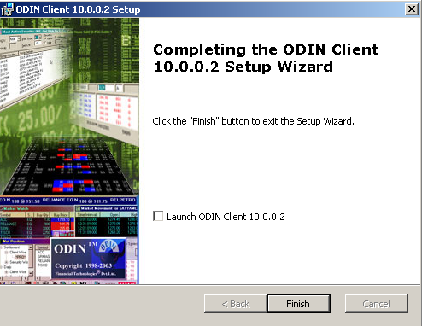

Follow the same Procedure for CLI32PDB_10X_MIG_SP07.exe

