Installation
of
ODIN 10x CNT Software

To download the CNT Setup please click on the below link and save it in your c-drive.
http://intra.cdequi.com/downloads/CNTSetup.zip
Extract the Files in Folder /CNTSetup
Open CNTSetup CNTCLIENTDisk1
Double click in setup.exe
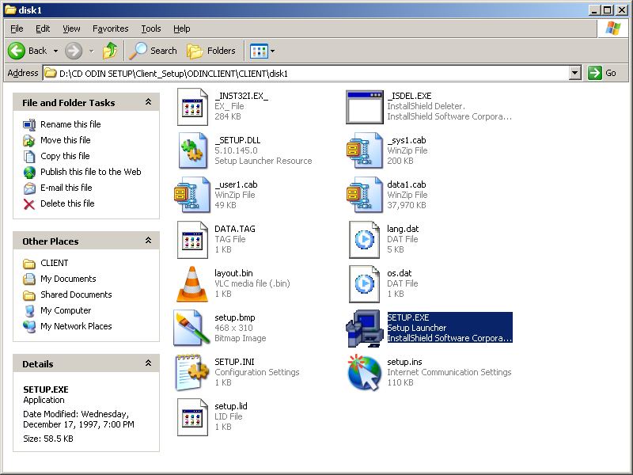

Click on OK
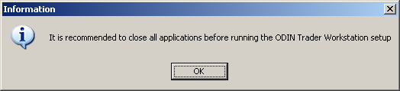

Click Next
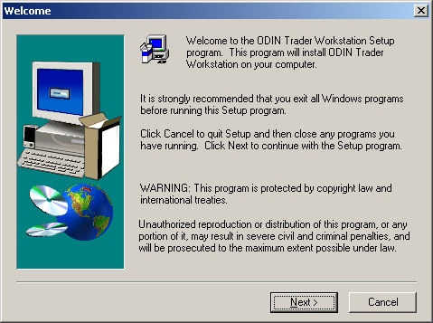
Click YES
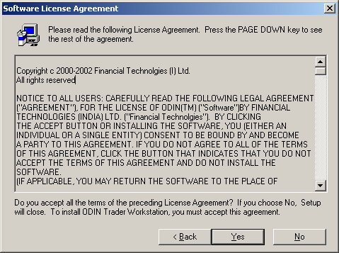

Click Next
Type Serial 91638-10001
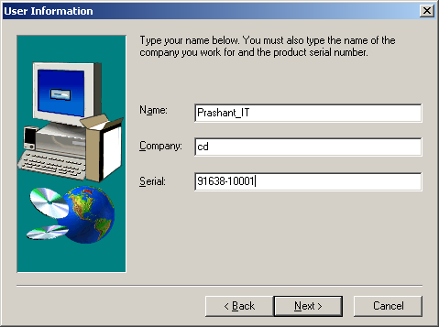

Click Next
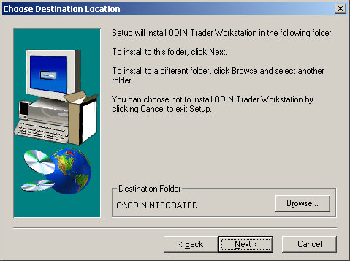

Click Next
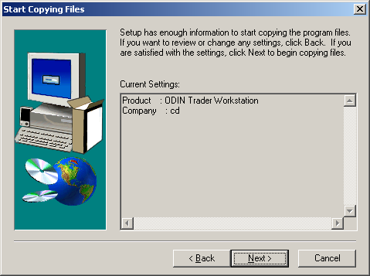

Click Next
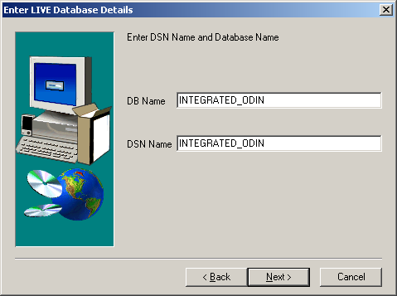

Click Next
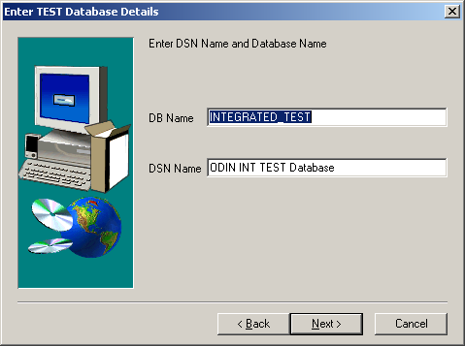

Click Next
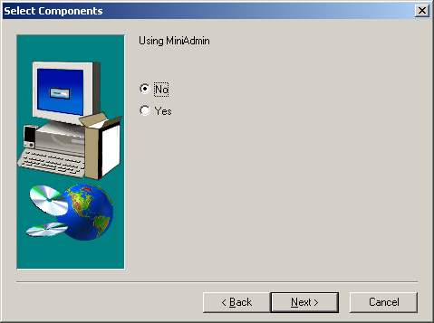

Click Next
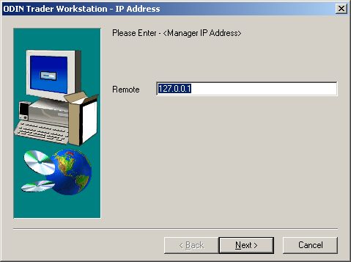

Click Next
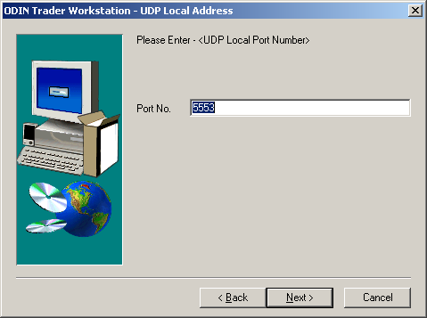

Click Next
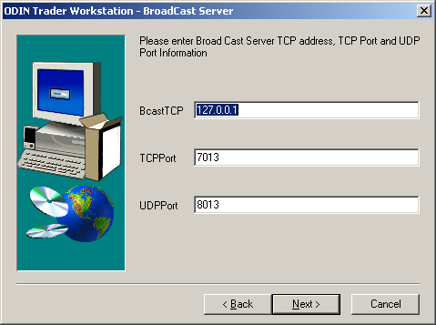

Click Next
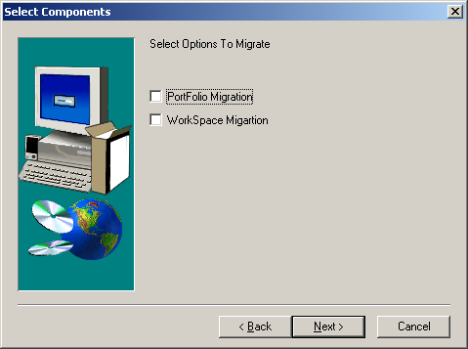

Click Finish
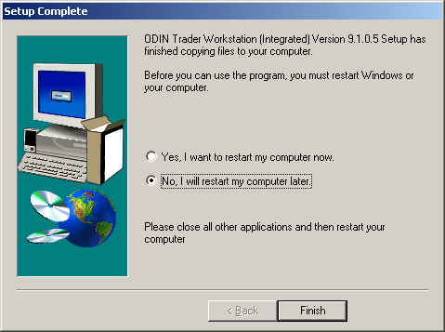

Open CNTSetup CNT\Report\ Dlls\disk1
Double click on setup.exe
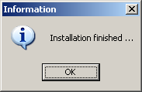
Click OK
Open CNTSetup \CNT\Sysdll\disk1
Double click on setup.exe
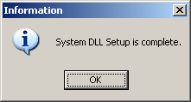
Click OK
Open CNTSetup\CNT\
Double click on vcredist_x86.exe
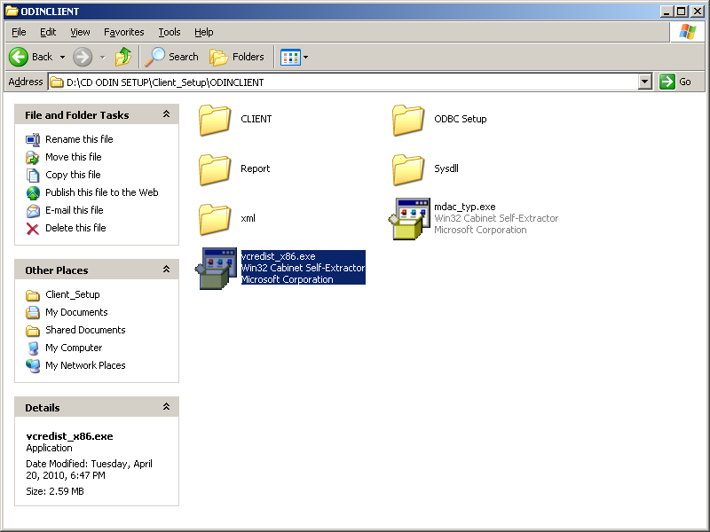
Click Yes
