Installation
of
ODIN 10x CNT Patches

To download the DIET Patches please click on the below link and save it in your c-drive.
http://intra.cdequi.com/downloads/CNTpatch10x.zip
Extract the Files in Folder /CNTpatch10x
Double click on CNT32BIN_10X_MIG_SP07.exe
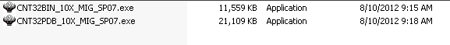
Click Next
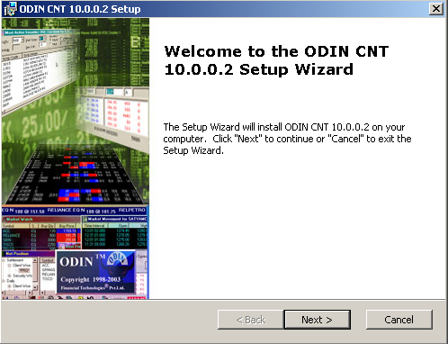

Click Next
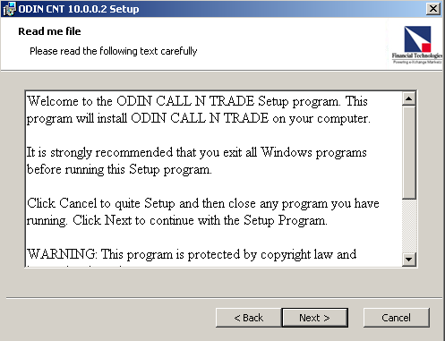
Click I Accept
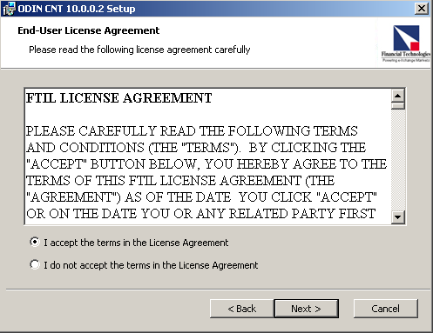
Click Next
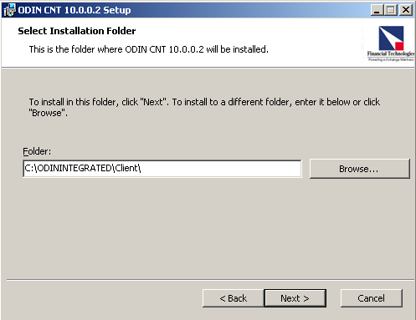
Click Install
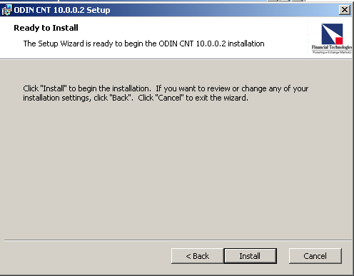

Click Finish
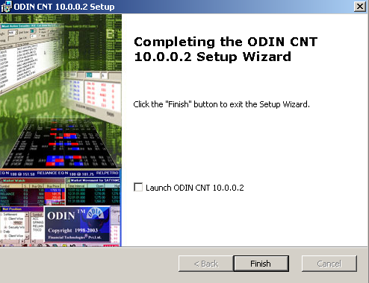

Follow the same Procedure for CNT32PDB_10X_MIG_SP07.exe

