Installation
of
ODIN 10x Diet Software

To download the DIET Setup please click on the below link and save it in your c-drive.
http://intra.cdequi.com/downloads/Diet_Setup.zip
Extract the Files in Folder /Diet_Setup
Double click on Diet_Setup_WITH_SIF.exe
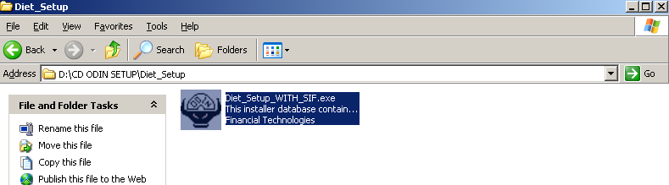

Click Next
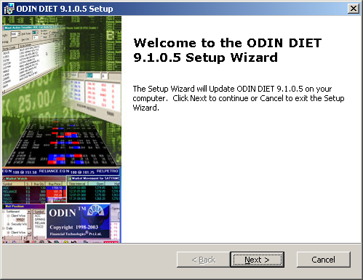

Click Next
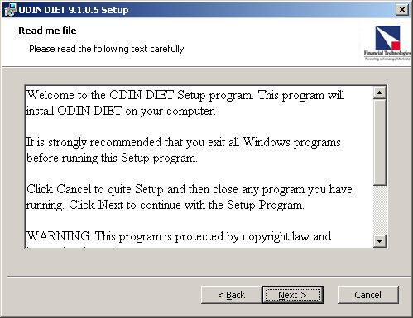
Click I Accept

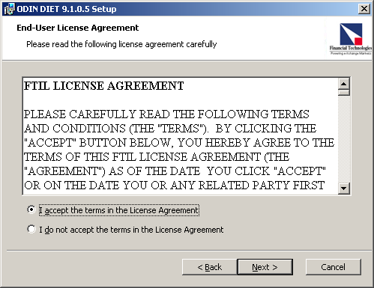

Click Next
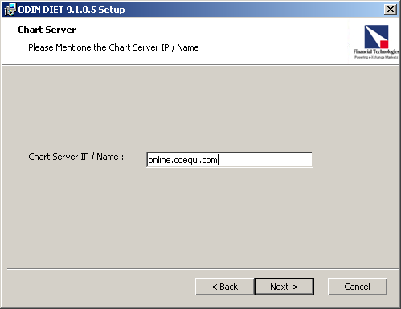

Click Install
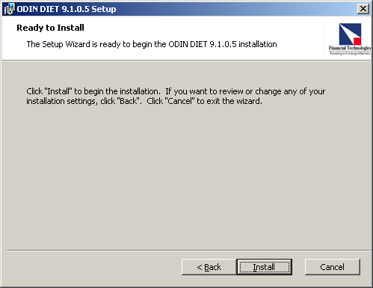

Click Finish
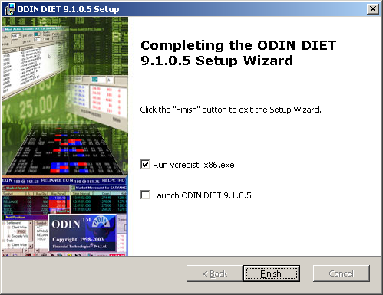
Click Yes
