To download the DIET Patches please click on the below link and save it in your c-drive.
http://intra.cdequi.com/downloads/Diet_Patch10x.zip
Extract the Files in Folder /Diet_Patch10x
Double click on DIET32BIN_10X_MIG_SP07.exe
Click Next
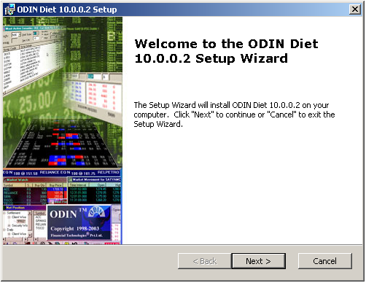
Click Next
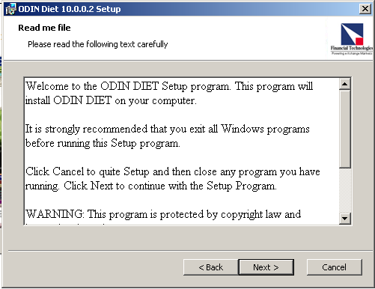
Click I Accept
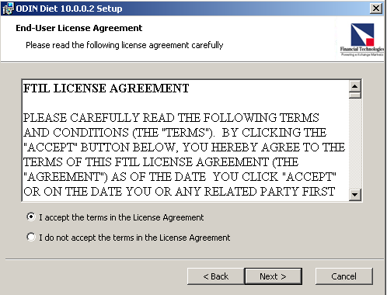
Click Next
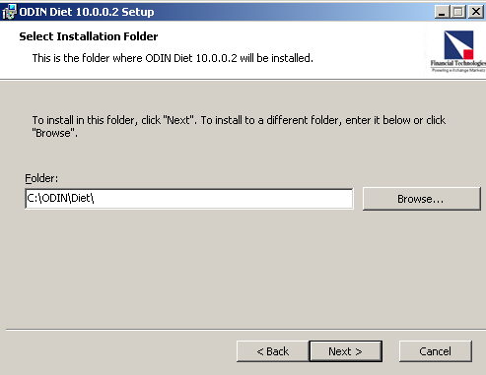

Click Install
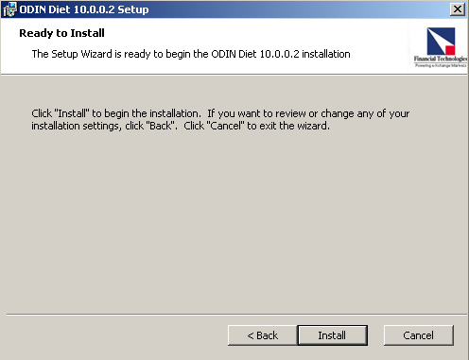
Click Finish
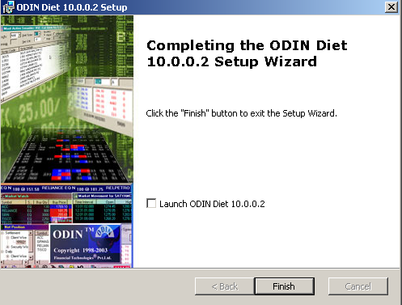
Follow the same Procedure for DIET32PDB_10X_MIG_SP07.exe

