Installation
of
Exodus Chat Software
Download Exodus File.Run Exodus 0.9.1.0 Setup
Click --> I Agree
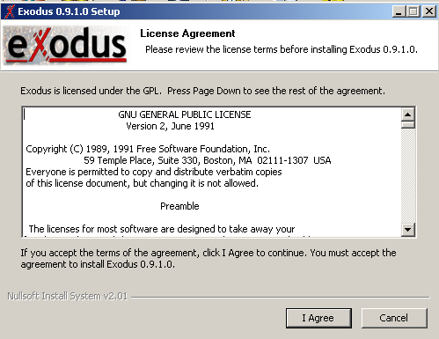
Click Next
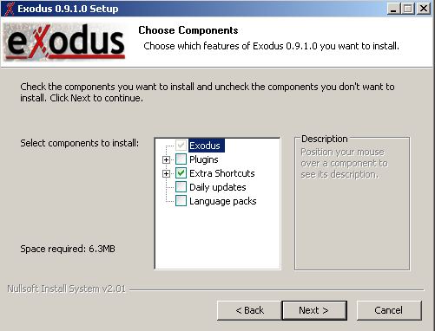
Click Next
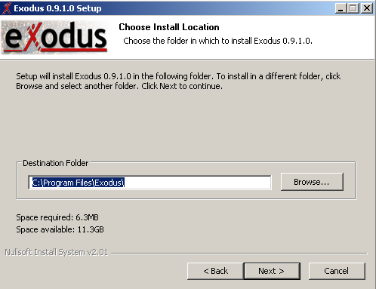
Click Install
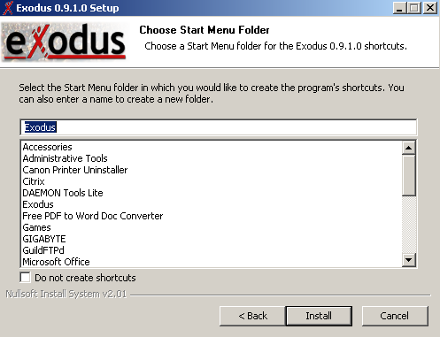
Click Next
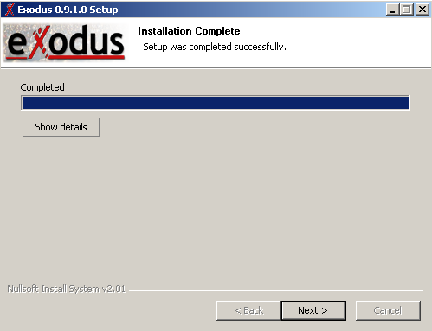
Click Finish
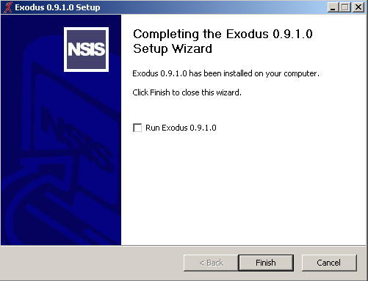

In Jabber Id type your Id e.g dilip.pradhan@chat.cdequi.com In Password field type password.

In resource select exodus.
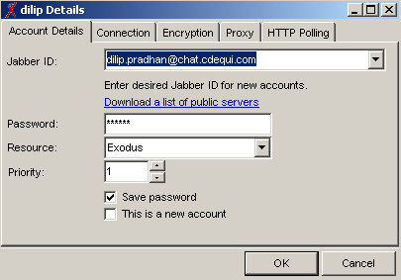
Click on Connection Tab

Remove click from Automatically discover host & port

Host : chat.cdequi.com

Port : 5222
