Spark IM Software Installation
To download the Spark Setup please click on the below link and save it in your c-drive.
http://intra.cdequi.com/downloads/spark_2_6_3.zip
Extract the Files in Folder / spark_2_6_3.exe

Double Click on spark_2_6_3.exe

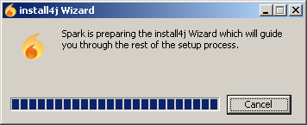

Click Next

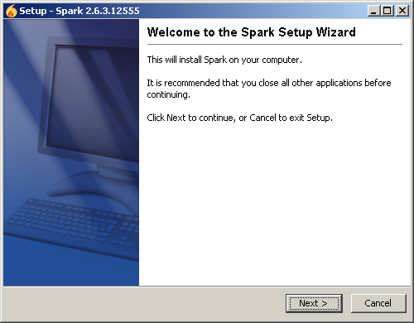

Click Next

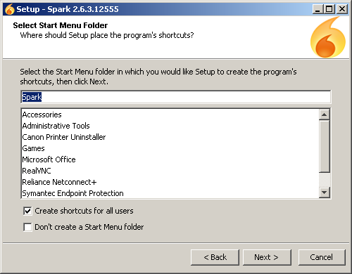

Click Next

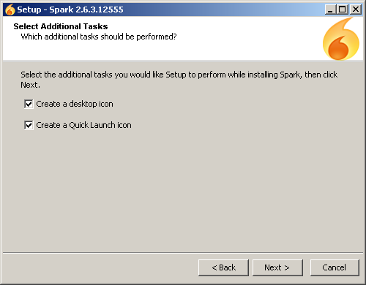

Please wait till it finishes.

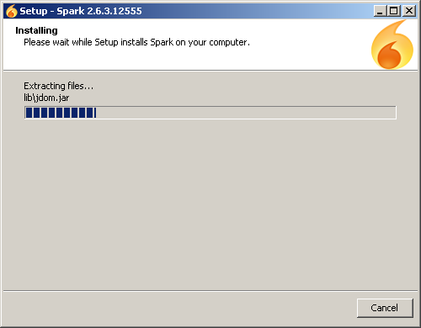

Click Finish

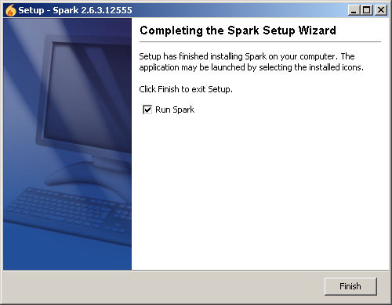

Click Advanced

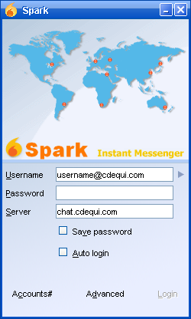

Insert the Connection as mentioned in the below mentioned screenshot and then click OK.

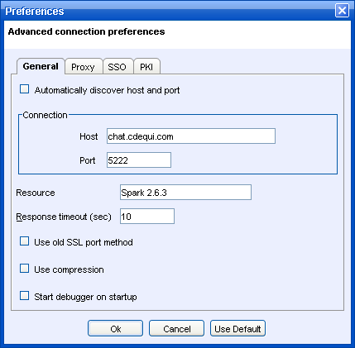

Put Username and Password and then click Login.

